**DESIGN AND FABRICATION OF SOLAR STILL WITH SELECTIVE COATING OVER A BASIN LINER**

**A CREATIVE AND INNOVATIVE PROJECT REPORT**

***Submitted by***

|  |  |
| --- | --- |
| **SURYA D** | **(2015 111 052)** |
| **GREASH K** | **(2016 111 030)** |
| **PUGAZHSELVAN T** | **(2016 111 078)** |

***to the***

# FACULTY OF MECHANICAL ENGINEERING

***in partial fulfillment for the award of the degree***

***of***

# BACHELOR OF ENGINEERING

***in***

**MECHANICAL ENGINEERING**



**COLLEGE OF ENGINEERING GUINDY**

**ANNA UNIVERSITY : CHENNAI 600 025**

**NOVEMBER 2019**

**ANNA UNIVERSITY : CHENNAI 600 025**

**BONA FIDE CERTIFICATE**

Certified that this project report “**Design and Fabrication of Solar Still with selective coating over a Basin liner**” is a bona fide work of

|  |  |
| --- | --- |
| **SURYA D** | **(2015 111 052)** |
| **GREASH K** | **(2016 111 030)** |
| **PUGAZHSELVAN T** | **(2016 111 078)** |
|  |  |

who carried out the project work under my supervision, for the partial fulfilment of the requirements for the award of the degree of Bachelor of Engineering in Mechanical Engineering. Certified further that to the best of my knowledge and belief, the work reported herein does not form part of any other project report or dissertation on the basis of which a degree or an award was conferred on an earlier occasion on these or any other candidates.

# 

|  |  |
| --- | --- |
| **Dr. Maj. S. RAJENDRA BOOPATHY**  Professor & Head  Department of Mechanical Engineering College of Engineering Guindy  Anna University, Chennai – 25. | **Mr. v. s VIGNESWARAN**  Teaching Fellow & Guide Department of Mechanical Engineering College of Engineering Guindy  Anna University, Chennai – 25. |

# ABSTRACT

Solar still uses a sustainable and pollution-free source to produce high quality water. The main limitation is low productivity and this has been the focus of intensive research. A major concern while increasing productivity is to maintain economic feasibility and simplicity. The efficiency of the solar still depends upon the absorptivity of basin liner. Our aim is to introduce the selective coating over the basin liner of the solar still in order to increase its absorptivity. Because the best way to increase the efficiency of solar still is to develop a new coating with nominal cost, ecofriendly and easily available material.

# ACKNOWLEDGEMENT

We are highly indebted to our guide **Mr. V. S. VIGNESWARAN,** Teaching Fellow, Institute for Energy Studies, Department of Mechanical Engineering, College of Engineering Guindy Campus, Anna University for his useful suggestion, moral support, sustained interests and encouragement throughout the project.

We consider it a privilege to thank **Dr. Maj. S. RAJENDRA BOOPATHY,** Professor and Head, Department of Mechanical Engineering, College of Engineering Guindy, Anna University, for providing facilities for the successful completion of the Project.

We owe our sincere thanks to our Project coordinator

**Dr. A. ELAYA PERUMAL,** Professor and Head, Engineering Design Division, Department of Mechanical Engineering, College of Engineering Guindy, Anna University, for providing us with all facilities for the project.

We are extremely grateful to our review committee members

**Dr. S. BALASIVANANDHA PRABU,** Professor, Central Workshop Division,

**Dr. G. SHIBU,** Associate Professor (Sr. Gr.), Engineering Design Division**,**

**Dr. M. R. SWAMINATHAN,** Associate Professor, Internal Combustion Engine Division,Department of Mechanical Engineering, College of Engineering Guindy, Anna University, for their valuable suggestions for this Project.

|  |  |  |
| --- | --- | --- |
| SURYA D | GREASH K | PUGAZHSELVAN T |
| 2015111052 | 2016111030 | 2016111078 |

**TABLE OF CONTENTS**

**CHAPTER NO. TITLE PAGE NO.**

**ABSTRACT iii**

**ACKNOWLEDGEMENT iv**

**LIST OF TABLES vii**

**LIST OF FIGURES viii**

**LIST OF SYMBOLS ix**

**1 INTRODUCTION 1**

1.1 GENERAL 1

1.2 SOLAR STILL 1

1.3 METHODOLOGY 3

**2 LITERATURE REVIEW 4**

2.1 INFERENCES 5

2.2 AIMS AND OBJECTIVES 5

**3 DESIGN AND FABRICATION OF**

**SOLAR STILL 6**

3.1 DESIGN OF SOLAR STILL 6

3.2 CONFIGURATION OF SOLAR STILL 8

3.3 INSULATION 9

**4 SELECTIVE COATING 10**

4.1 CARBON BLACK 10

4.2 SPECIALTY CARBON BLACK 10

4.2.1 Vulcan XC 72R 10

4.3 COATING PREPARATION 11

4.4 SELECTIVE COATING PROPERTIES 12

**5 PERFORMANCE EVALUATION 13**

5.1 OBSERVATIONS 13

5.2 CALCULATIONS 15

5.2.1 Without selective coating 15

5.2.2 With selective coating 15

**6 RESULTS AND DISCUSSION 16**

6.1 COMPARISON OF THERMAL

PERFORMANCE WITH AND

WITHOUT SELECTIVE COATING 16

6.2 INFERENCES 16

**7 CONCLUSION 18**

**REFERENCES 19**

**LISTS OF TABLES**

**TABLE NO. TITLE PAGE NO.**

1.1  Solar still configuration 8

1.2 Paint specifications 11

1.3 Temperature marking without selective

coating on 19:11:2019 13

1.4 Temperature marking with selective

coating on 19:11:2019 14

**LIST OF FIGURES**

**FIGURE NO. TITLE PAGE NO.**

1.1 Schematic diagram of solar still 2

1.2 Isometric view (CAD Model) 7

1.3 Side view 7

1.4 Front view 8

1.5 Fabricated solar still 9

1.6 Carbon black 10

1.7 Cabot Vulcan XC 72R 11

1.8 Formulated paint 12

1.9 Selective coated absorber plate 12

2.0 Experimental setup (Temperature marking) 14

2.1 Comparison of thermal efficiency 16

2.2 Time vs Temperature, Irradiation plot

(without selective coating) 17

2.3 Time vs Temperature, Irradiation plot

(with selective coating) 17

**LIST OF SYMBOLS**

ⴄ - Thermal efficiency

m - Mass of water in kg

I - Average incident radiation

T - Time in hrs

A - Area of the absorber plate

J - Joule

W - Watt

∆Hvap - Latent heat of vaporization

**CHAPTER 1**

**INTRODUCTION**

**1.1 GENERAL:**

The shortage of drinking water is expected to be the biggest problem of the world in this century due to unsustainable consumption rates and population growth. Pollution of fresh water resources (rivers, lakes, and underground water) by industrial wastes has heightened the problem. About 70% of the earth is covered by water, and sea water represents about 97% of the water on the planet, and the remaining is fresh water; thus there is a shortage of potable water in many

countries around the world. The rural and remote regions in the Middle East countries do not have access to good quality drinking water and as a result they relied on low cost options for producing water from salty aquifers such as solar

desalination. Many researchers have developed mathematical models, and experimentally tried to improve the design of the conventional solar still in order to increase its daily productivity. Our aim is to introduce the selective coating over the absorber plate to increases the water temperature and thereby improving the performance of the solar still. Because it is cost effective compared to other methods which are used to improve the performance of the system.

**1.2 SOLAR STILL:**

A solar still distils water with substances in dissolved in it by using the heat of the Sun to evaporate water so that it may be cooled and collected, thereby purifying it. They are used in areas where drinking water is unavailable, so that clean water is obtained from dirty water or from plants by exposing them to sunlight.

In the solar still water is evaporated and condensed simultaneously inside an air tight chamber. The basin of the still is generally constructed using galvanized iron sheet and painted with black mutty paint to absorb solar radiation effectively. A transparent glass sheet is used for enclosing the still at the top. The still is made air tight by sealing the system using silicone sealant. A channel is affixed to the lower end of the glazing for the collection of the distillate output. The still is usually insulated on its side and bottom to reduce the heat loss.

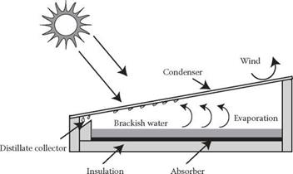

Figure 1.1: Schematic diagram of solar still

The glazing is tilted and fixed to transmit maximum solar radiation falling on it. The short-wave solar radiation from the sun passes via the glazing and it is absorbed by the basin of the still. This heat is used to evaporate the water in the basin. The evaporated water moves upwards and gets condensed on the inner surface of the glazing. The condensed droplets reach the channel affixed to the lower end of the glazing surface by tickling downwards due to inclination of the glazing and gravitational force. The water in the channel is moved to storage container via pipe. As water is not boiled in solar still, the taste of distillate water produced by solar still is much better than the water produced by steam distillation.

|  |
| --- |
| Literature review |

**1.3 METHODOLOGY:**

|  |
| --- |
| Design of Solar Still |

|  |
| --- |
| Fabrication of Solar Still |

|  |
| --- |
| Performance evaluation of Solar Still without coating |

|  |
| --- |
| Performance evaluation of Solar Still after applying selective coating over the absorber plate |

|  |
| --- |
| Comparison of result |

|  |
| --- |
| Conclusion |

**CHAPTER 2**

**LITERATURE REVIEW**

*Duffie.* (1962) stated that the material used for constructing basin liner must possess high absorptivity to absorb the maximum solar radiation falling on it.

*A* *Hachemi*. (1998) concluded that the black painted absorber plate presents a high emissivity attaining 0.99 loses by radiation to the ambient and the selective absorber has only a low emissivity value of 0.15.

[*Kabeel*](https://www.sciencedirect.com/science/article/pii/S0959652618339015#!)*, A.E., et al.* (2019) reported that by coating the [absorber plate](https://www.sciencedirect.com/topics/engineering/absorber-plate) of a solar still with TiO2 nanoparticles doped in black paint the efficiency of the still increased by 6.1% when compared to conventional solar still. This increment in efficiency in solar still when the absorber plate was coated with Titanium Oxide (TiO2) nanoparticles doped in black paint can be attributed to the increased in average water temperature of the still by 1.5°C than that of the conventional still.

*Malik et al.* (1982) reported that the basin of solar still reflects around 11% of solar radiation reaching it but this loss can be decreased reduced by increasing the basin water absorption coefficient.

*Pettit, R. B., & Sowell, R. R.* (1976) concluded that the resin system plays a vital role in increasing the emittance of the coating. New resin system should be found in order to reduce the emittance.

*Tiwari et al.* (2006) stated that the yield of the solar still increases with decrease in water depth because of increase in evaporative and convective heat transfer coefficient taking place within a still.

**2.1 INFERENCES:**

The following points have been observed from the literature review discussed above,

The solar still with selective coating on absorber plate increases its productivity by reducing its energy loses from re-radiation energy.

The resin which is used for preparing the coating should not have to increase or raise the emittance of the material. Because this will affect the performance of the solar still.

The selective coating material must have a property of high absorptivity and low emissivity. The coating with this properties is much suited for increasing the water temperature in the container.

Paint prepared from commodity (ASTM Carbon Black) carbon black contains impurities which affects the thermal performance of coating.

**2.2 AIMS AND OBJECTIVES:**

* + Find the cheap and best option of pigment and resin for selective coating and prepare the selective coating.
  + Performance analysis of solar still with and without selective coating
  + Calculate the thermal efficiency and compare the result.

**CHAPTER 3**

**DESIGN AND FABRICATION OF SOLAR STILL**

There are various types of Solar still and the key components of these system are; a blackened absorber plate (normally made from a thin Galvanized Iron sheet), a thin transparent glass (glazing), and the insulation material. In brief, a transparent glass is used to allow solar radiation inside the solar still and an Al or G.I(Galvanized Iron) blackened thin sheet is used to fabricate the side wall and absorber material. An Insulation material is used to reduce the conduction loses (from the sides and bottom of the system).

**3.1 DESIGN OF SOLAR STILL:**

* Daily yield = 1.65 litre/day
* Available solar radiation on location = 5 kWh/m2
* Efficiency of solar still = 40 %
* Amount of solar radiation that can be utilised = 0.4*5

= 2 kWh/m2/day

= 7200 kJ/m2/day

* Energy required per litre of water (∆Hvap) = 2260 kJ
* Yield produced per day = 7200 / 2260

= 3.18 litres/m2/day

* Total area of still required = 1.65 / 3.18

= 0.52 m2

* Glass cover area = 1*0.52

= 0.52 m2

* Brine height considered = 2 cm

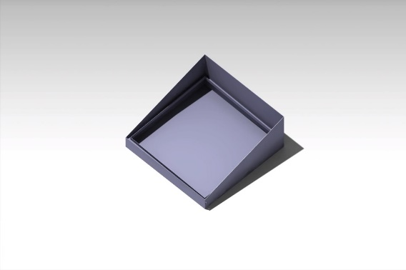

Figure 1.2: Isometric view (CAD Model)

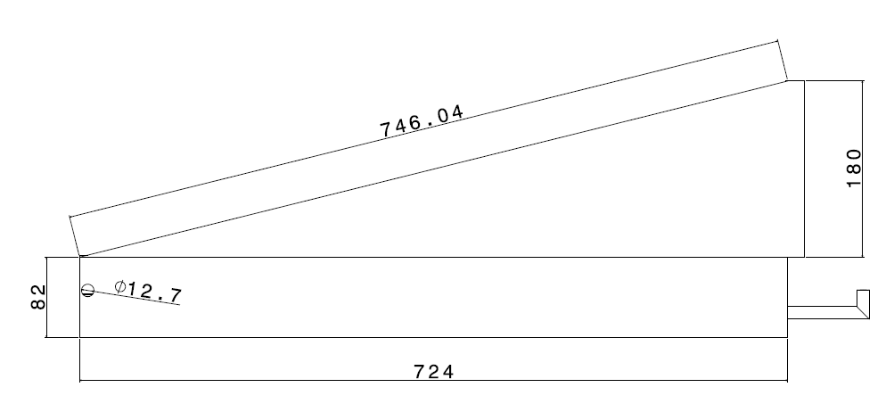

Figure 1.3: Side View

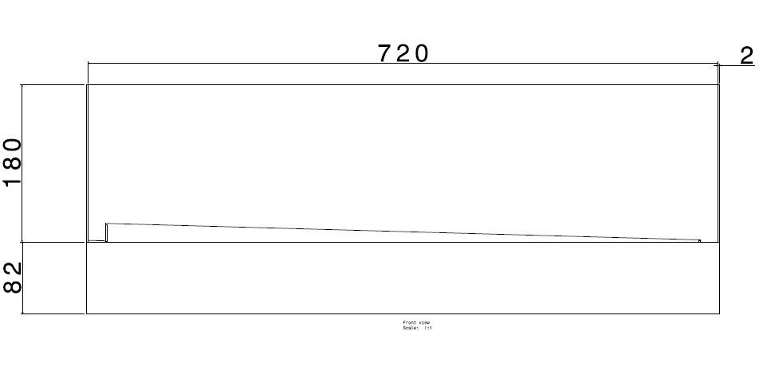

Figure1.4: Front view

**3.2 CONFIGURATION OF SOLAR STILL:**

Table 1.1 Solar Still Configuration

|  |  |
| --- | --- |
| Length | 724 mm |
| Breadth | 724 mm |
| Height on smaller side | 82 mm |
| Height on larger side | 262 mm |
| Top Glass material | 4 mm Toughened Glass |
| Side wall and absorber material | Galvanized Iron (G.I) |
| Inclination of top glass | 13.25° |

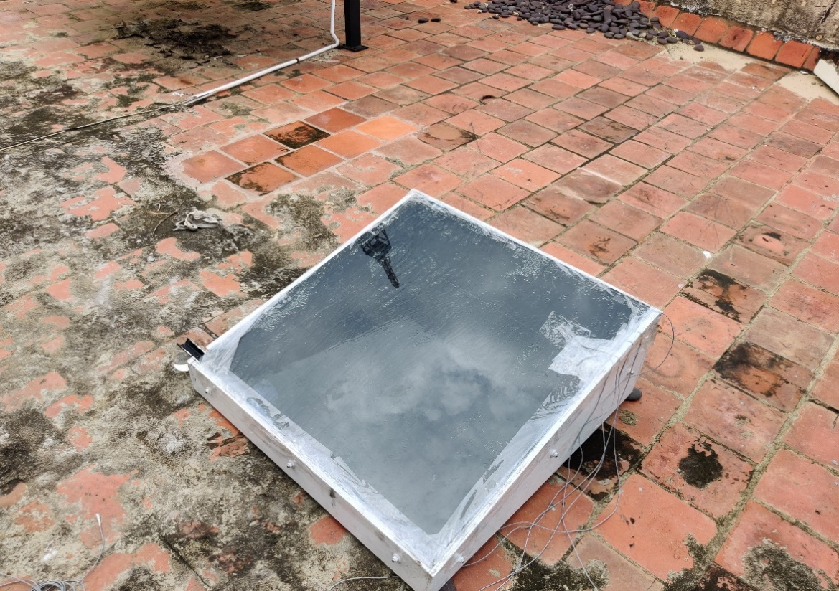

Figure 1.5: Fabricated Solar Still

**3.3 INSULATION:**

Thermal insulation is the simplest way to prevent heat loses and to achieve economy in energy usage especially in solar thermal systems. Thermal insulation serves many significant functions such as, to conserve energy, to reduce heat loss or heat gain, to maintain an efficient operation of the system, to assist in sustaining a product at a constant temperature. We have used wood which is of 2cm thickness around the sides and edges of the duct as an insulation material.

**CHAPTER 4**

**SELECTIVE COATING**

**4.1 CARBON BLACK:**

Carbon Black is a specific type of elemental carbon in the form of colloidal particles that is generated or produced through incomplete combustion process or the thermal decomposition of gaseous or liquid hydrocarbons under controlled conditions. It occurs as a black fine dusty powder that must be differentiated from the undefined byproducts soot and diesel exhaust particulates generated during coal or hydrocarbon combustion. Carbon Black consist of more than 96 percent of amorphous carbon and small amount of oxygen, hydrogen, nitrogen, and sulfur.

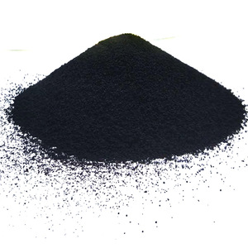

Figure 1.6: Carbon Black

**4.2 SPECIALTY CARBON BLACK:**

Any carbon black which is other than ASTM series of carbon black is said to be specialty carbon black. Carbon black in natural itself acts as a conductive filler, by certain modification this property can be increased.

**4.2.1 Vulcan XC 72R:**

Vulcan XC 72R is a pure carbon black which has a very good conductive and absorptive property, which is being used as the key ingredients in our selective coating. Vulcan XC 72R has a Brunauer–Emmet–Teller (BET) surface area of 241 m2 /gand fine average particle size. Vulcan XC 72R’s average particle size will be 40nm.

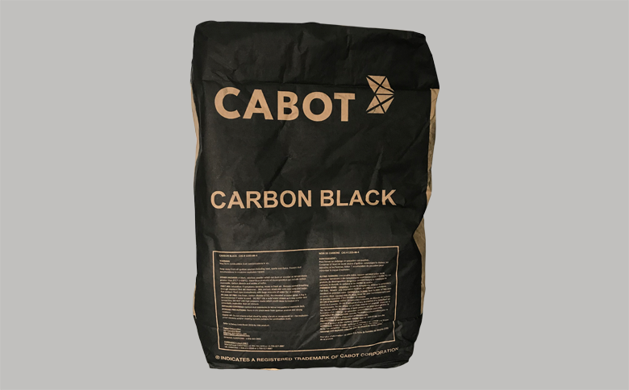

Figure 1.7: Cabot Vulcan XC 72R

**4.3 COATING PREPARATION:**

Coating was prepared using Cabot Vulcan XC 72R. Coating was purely water base which is completely APEO (Alkylphenol ethoxylates) free raw material. The below raw material were grinded along with the pigment in a Sand Mill to form the selective coating. We have choosen to go with high PVC (Pigment Volume Concentration) paint, since the role of pigment in the paint is very much needed to obtain our desired thermal conductivity.

Table 1.2 Paint Specification

|  |  |  |
| --- | --- | --- |
| Pigment | Caron Black | 40% |
| Binder | Acrylic Resin | 25% |
| Water | Water | 33% |
| Thickener | Acrylic Thickener | 2% |

The prepared coating was applied over the absorber plate and the performance evaluation is done for both selective coating and non selective coating.

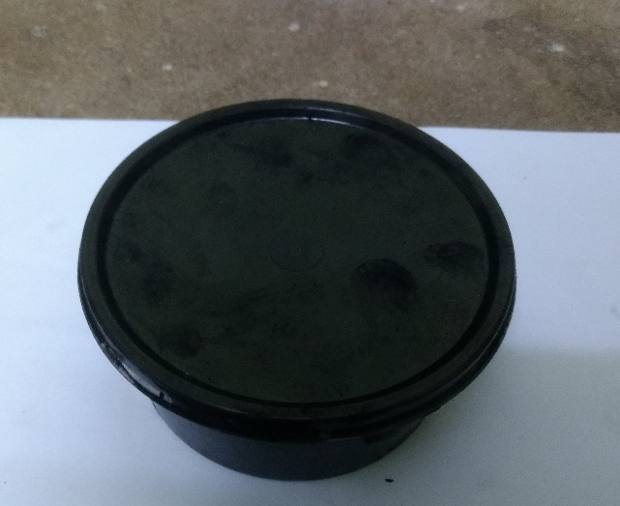

Figure 1.8: Formulated Paint

**4.4 SELECTIVE COATING PROPERTIES:**

* High conductivity (0.67W/mK) at relatively low loading levels.
* Excellent long term durability (does not lose absorptivity over time).
* Excellent resistance to UV and moisture degradation.

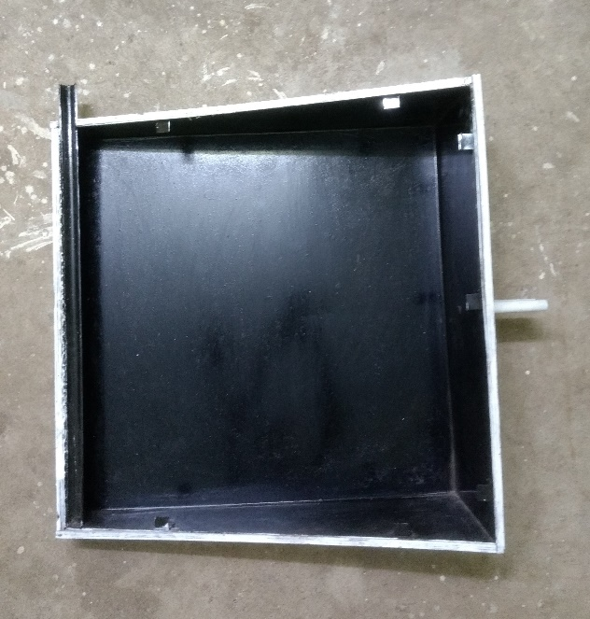

Figure 1.9: Selective coated absorber plate

**CHAPTER 5**

**PERFORMANCE EVALUATION**

**5.1 OBSERVATION:**

Solar Still is made to work with two different coating viz. normal matte black paint and selective coating. The temperature markings are taken at different locations of the solar still as mentioned below,

**T1** - Temperature of Basin Liner

**T2** - Water Surface Temperature

**T3** - Air water gap Temperature

**T4** - Temperature at the lower side of the glass

**T5** - Temperature at the upper side of the glass

Table 1.3 Temperature marking without selective coating on 19:11:2019

|  |  |  |  |  |  |  |
| --- | --- | --- | --- | --- | --- | --- |
| **Time** | **T1 (°C)** | **T2 (°C)** | **T3 (°C)** | **T4 (°C)** | **T5 (°C)** | **Solar Radiation**  **(W/m2)** |
| **10:30 am** | 47.0 | 46.7 | 48.2 | 44.0 | 43.0 | 642 |
| **11:00 am** | 49.9 | 49.1 | 50.1 | 46.3 | 45.8 | 355 |
| **11:30 am** | 55.1 | 51.4 | 52.2 | 47.1 | 46.1 | 631 |
| **12:00 pm** | 54.0 | 52.5 | 53.4 | 50.7 | 47.2 | 649 |
| **12:30 pm** | 54.3 | 53.4 | 53.7 | 48.5 | 43.7 | 767 |
| **01:00 pm** | 55.8 | 54.3 | 55.4 | 45.3 | 43.6 | 710 |
| **01:30 pm** | 48.1 | 47.9 | 52.1 | 43.9 | 39.8 | 350 |

Table 1.4 Temperature marking with selective coating on 19:11:2019

|  |  |  |  |  |  |  |
| --- | --- | --- | --- | --- | --- | --- |
| **Time** | **T1 (°C)** | **T2 (°C)** | **T3 (°C)** | **T4 (°C)** | **T5 (°C)** | **Solar Radiation**  **(W/m2)** |
| **10:30 am** | 47.6 | 47.1 | 52.4 | 46.2 | 45.0 | 642 |
| **11:00 am** | 50.5 | 49.6 | 54.9 | 47.5 | 45.3 | 355 |
| **11:30 am** | 56.9 | 52.6 | 54.5 | 47.8 | 43.7 | 631 |
| **12:00 pm** | 57.3 | 54.7 | 56.1 | 52.8 | 46.9 | 649 |
| **12:30 pm** | 59.7 | 56.6 | 58.8 | 54.8 | 49.5 | 767 |
| **01:00 pm** | 63.5 | 56.8 | 58.4 | 51.0 | 48.5 | 710 |
| **01:30 pm** | 58.3 | 53.4 | 59.1 | 52.1 | 40.2 | 350 |

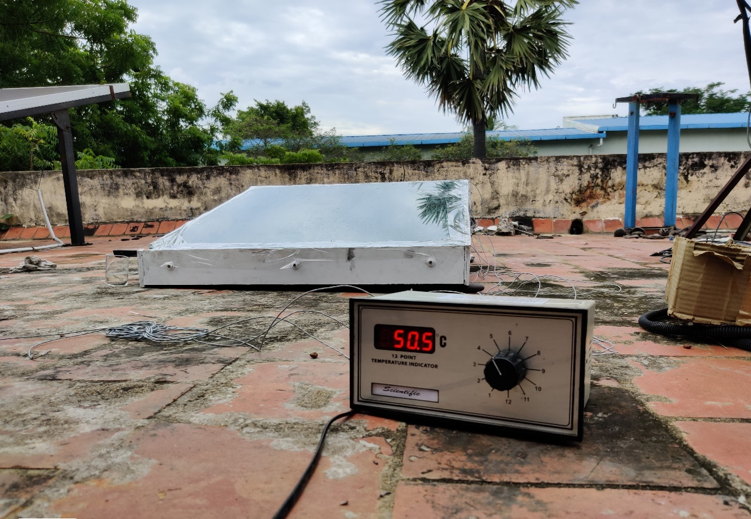

Figure 2.0: Experimental setup (Temperature marking)

**5.2 CALCULATION:**

The performance evaluation is done by using the observed temperature reading,

Efficiency = Energy used for water distillation / Solar energy(direct)

ⴄ = [ m * ∆Hvap] / [ Σ I * t * A ]

where ∆Hvap =2260 (kJ/kg)

**5.2.1 Without selective coatings:**

ⴄ =  [ m * ∆Hvap] / [  Σ I * t * A ]

= [ 0.290 * 2260 ] / [ 0.580 * 3.0 * 3600 * 0.52 ]

ⴄ = 20.12 %

**5.2.2 With selective coating:**

ⴄ = [ m *  ∆Hvap] / [  Σ I *t *A ]

= [ 0.360 * 2260] / [0.580 * 3.0 * 3600 * 0.52 ]

ⴄ = 25.97 %

**CHAPTER 6**

**RESULTS AND DISCUSSION**

**6.1 COMPARISON OF THERMAL PERFORMANCE WITH**

**AND WITHOUT SELECTIVE COATING:**

The intensity of solar radiation was observed throughout the day time. We have noticed that the solar radiation varied from 350 to 767 W/m2 on 19th November 2019.

The peak temperature of the basin liner plate went to 55.8°C when using without selective coating over the absorber plate of the still.

The peak temperature of the basin liner plate went to 63.5°C when using selective coating over the absorber plate of the still.

The thermal efficiency for without selective coating is 20.12% and with selective coating is 25.97%. This lower efficiency is due to poor weather condition available at the time of taking reading between 10:30 am to 1:30 pm.

**6.2 INFERENCES:**

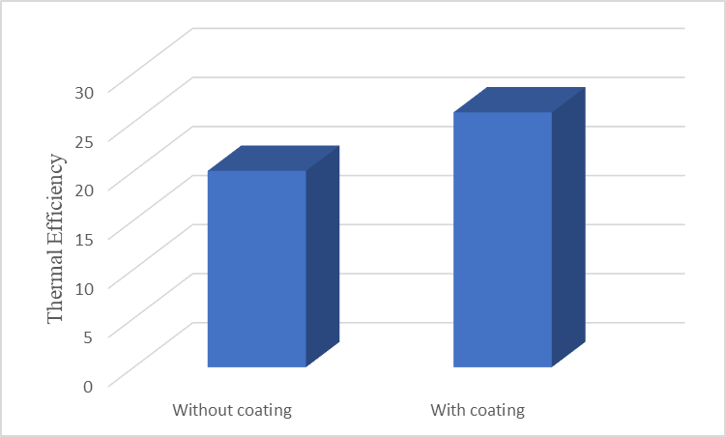

Figure 2.1: Comparison of Thermal efficiency

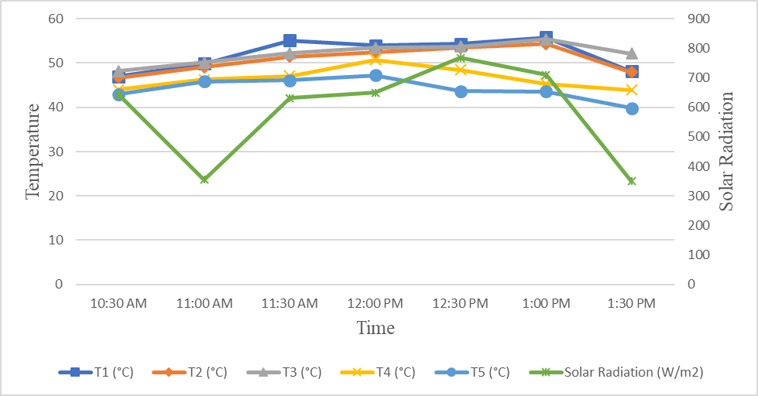

Figure 2.2: Time vs Temperature, Solar Radiation plot (without selective coating)

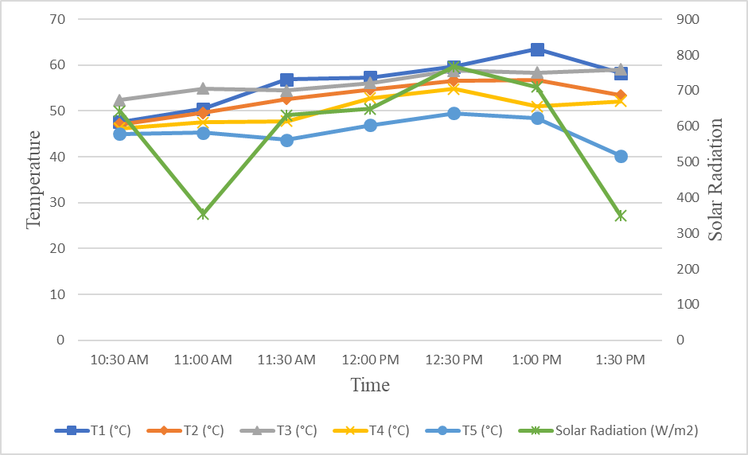

Figure 2.3: Time vs Temperature, Solar Radiation plot (with selective coating)

**CHAPTER 7**

**CONCLUSION**

During this project phase, we have fabricated a solar still and prepared a selective coating with a special type of carbon black and applied the same over the absorber plate. The main aim is to increase the absorber plate temperature with the help of this selective coating.

We have done the performance evaluation of solar still which was painted with selective coating and without selective coating and have concluded the following,

* Peak temperature of the absorber plate went up to 55.8°C when using without selective coating and a temperature of 63.5°C was observed when using with selective coating.
* Overall thermal efficiency of the solar still has been increased to 5.85% when using selective coating.
* The selective coating formulation can be used as a guideline formulation to formulate different coatings with different kinds of carbon black.

**REFERENCES**

[1] Duffie, (1962), ‘New materials in solar energy utilization’ *Solar Energy,*

*Vol.6, Issue 3, Pages 77-120.*

[2] Hachemi A, (1998), ‘Comparative study of thermal performance of solar

collectors with and without selective absorber plate’ *Renewable Energy,*

*Vol.13, Issue 4, Pages 439-451.*

[3] [Kabeel](https://www.sciencedirect.com/science/article/pii/S0959652618339015#!), A,E., et al, (2019), ‘Effectof water depth on a novel absorber plate

of pyramid solar still coated with TiO2 nano black paint’ *Journal of Cleaner*

*Production, Vol.213, Pages 185-191****.***

[4] Malik et al, (1982), ‘Solar Distillation: A Practical Study of a Wide Range

of Stills and Their Optimum Design, Construction and Performance’ *First*

*Edition, Pergamon Press, Oxford.*

[5] Pettit, R. B., & Sowell, R. R*,* (1976), ‘Solar absorptance and emittance

properties of several solar coatings’ *Journal of Vacuum Science and*

*Technology 13, 596.*

[6] Tiwari et al, (2006), ‘Effect of water depths on heat and mass transfer in a

passive solar still: in summer climatic condition’ *Desalination, Vol.195, Issues 1-3, Pages 78-94.*